**CASE STUDY SCREENSHOTS OF GITHUB ACTIONS**

Name : Akshay Rai   
Email : [Akshay.Rai@shell.com](mailto:Akshay.Rai@shell.com)  
  
CODE STRUCTURE WITH MAIN JAVA AND TEST JAVA FILES-  
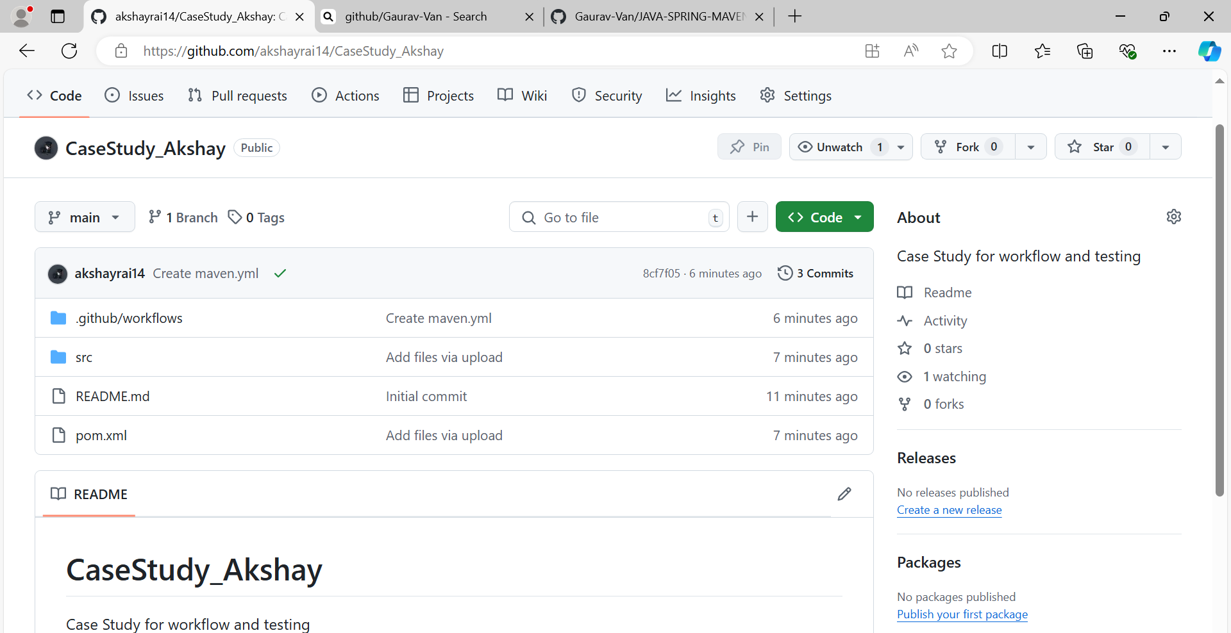

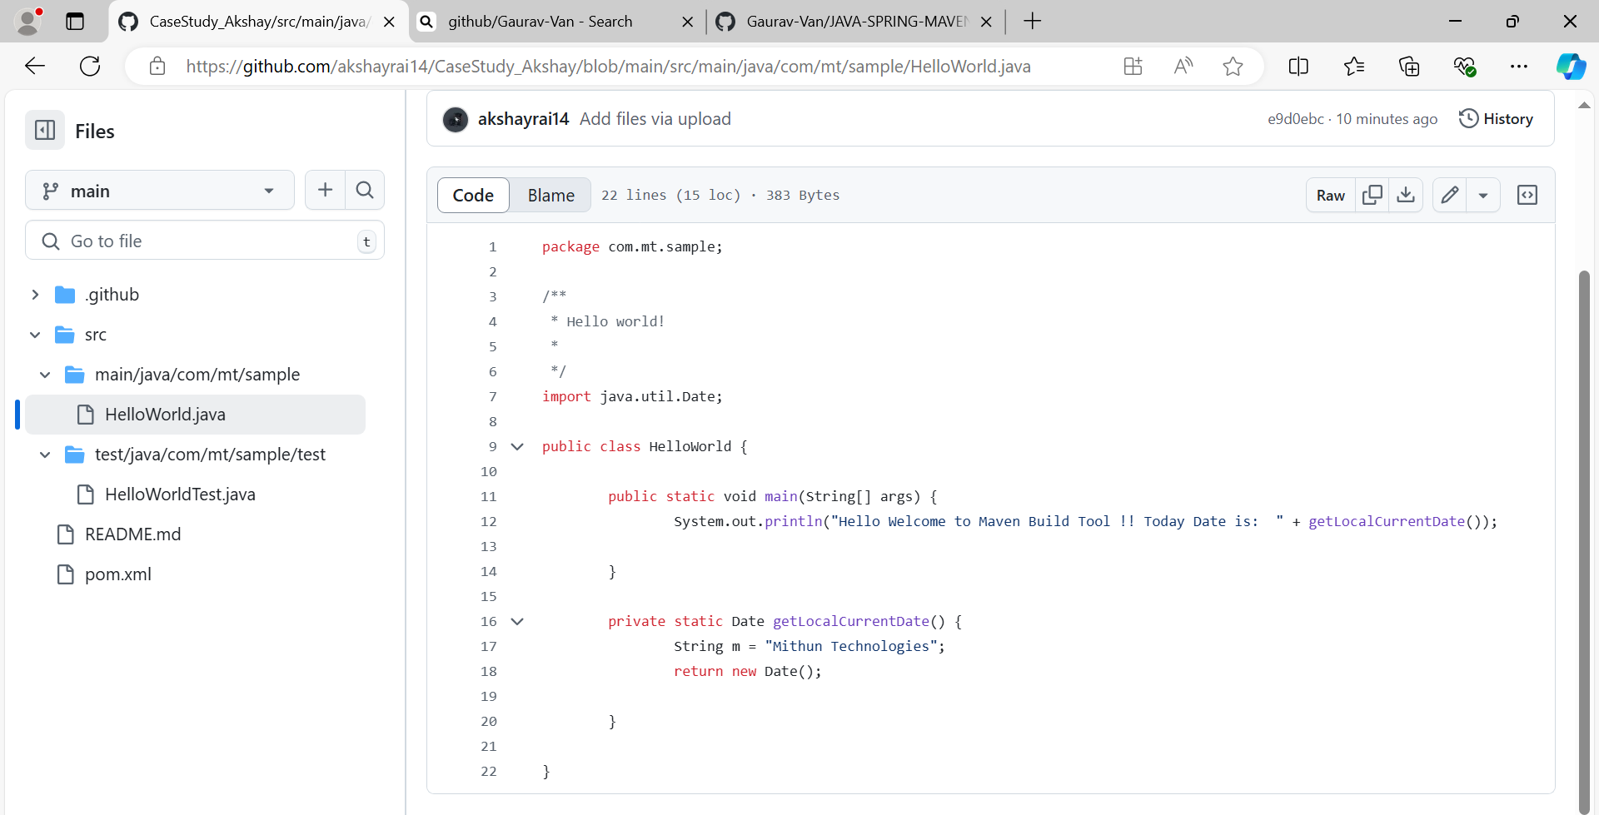

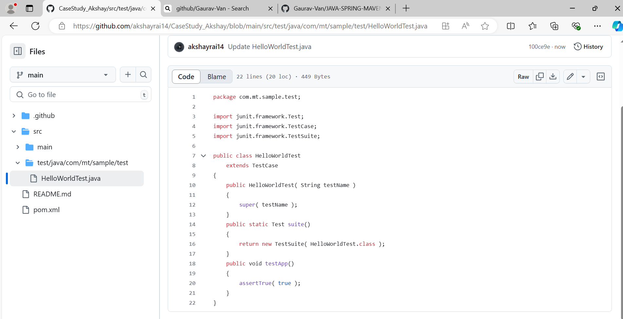

INITIAL BUILD SUCCESS-  
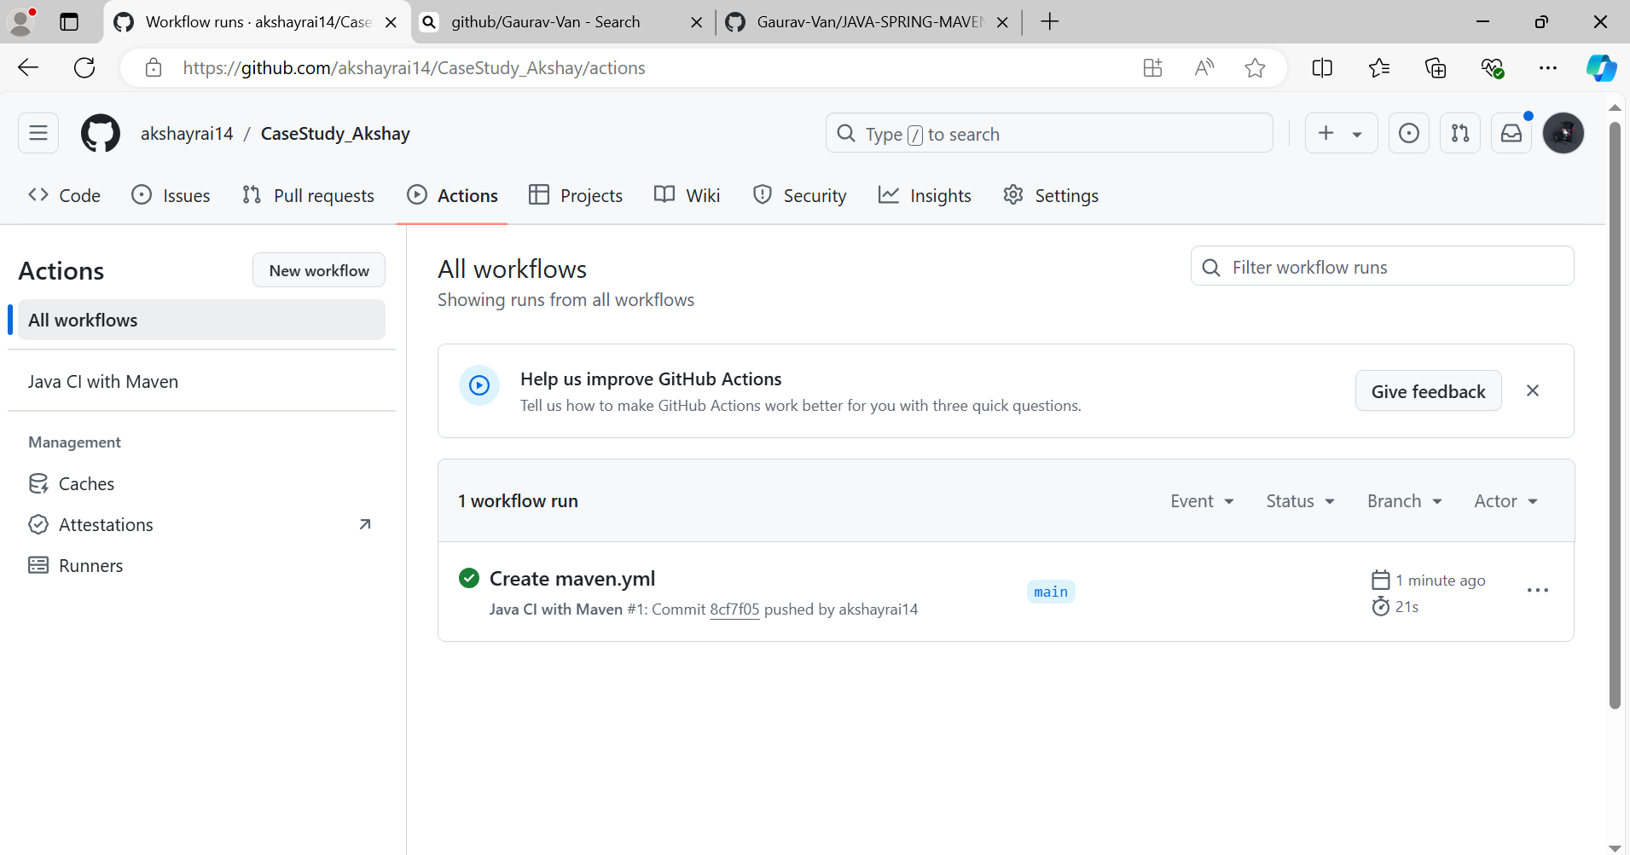

CHANGES IN THE GITHUB CODE-  
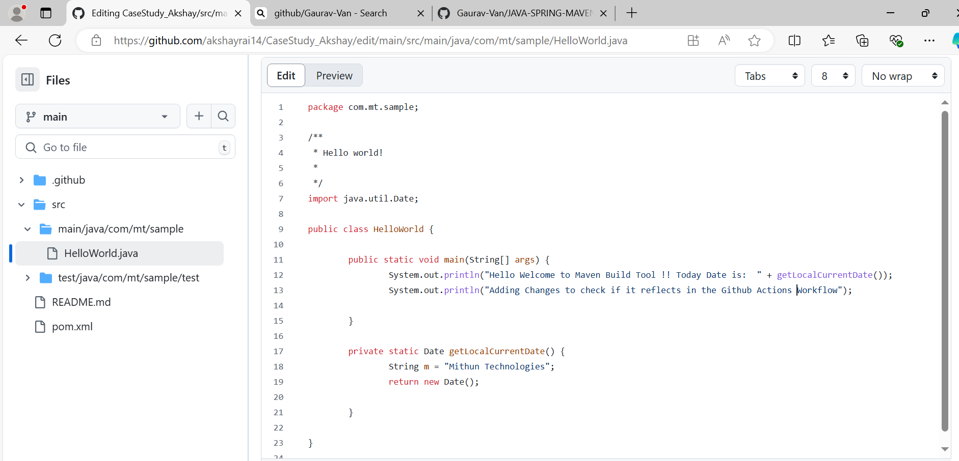  
  
Maven.yml and it’s initial build-  
  
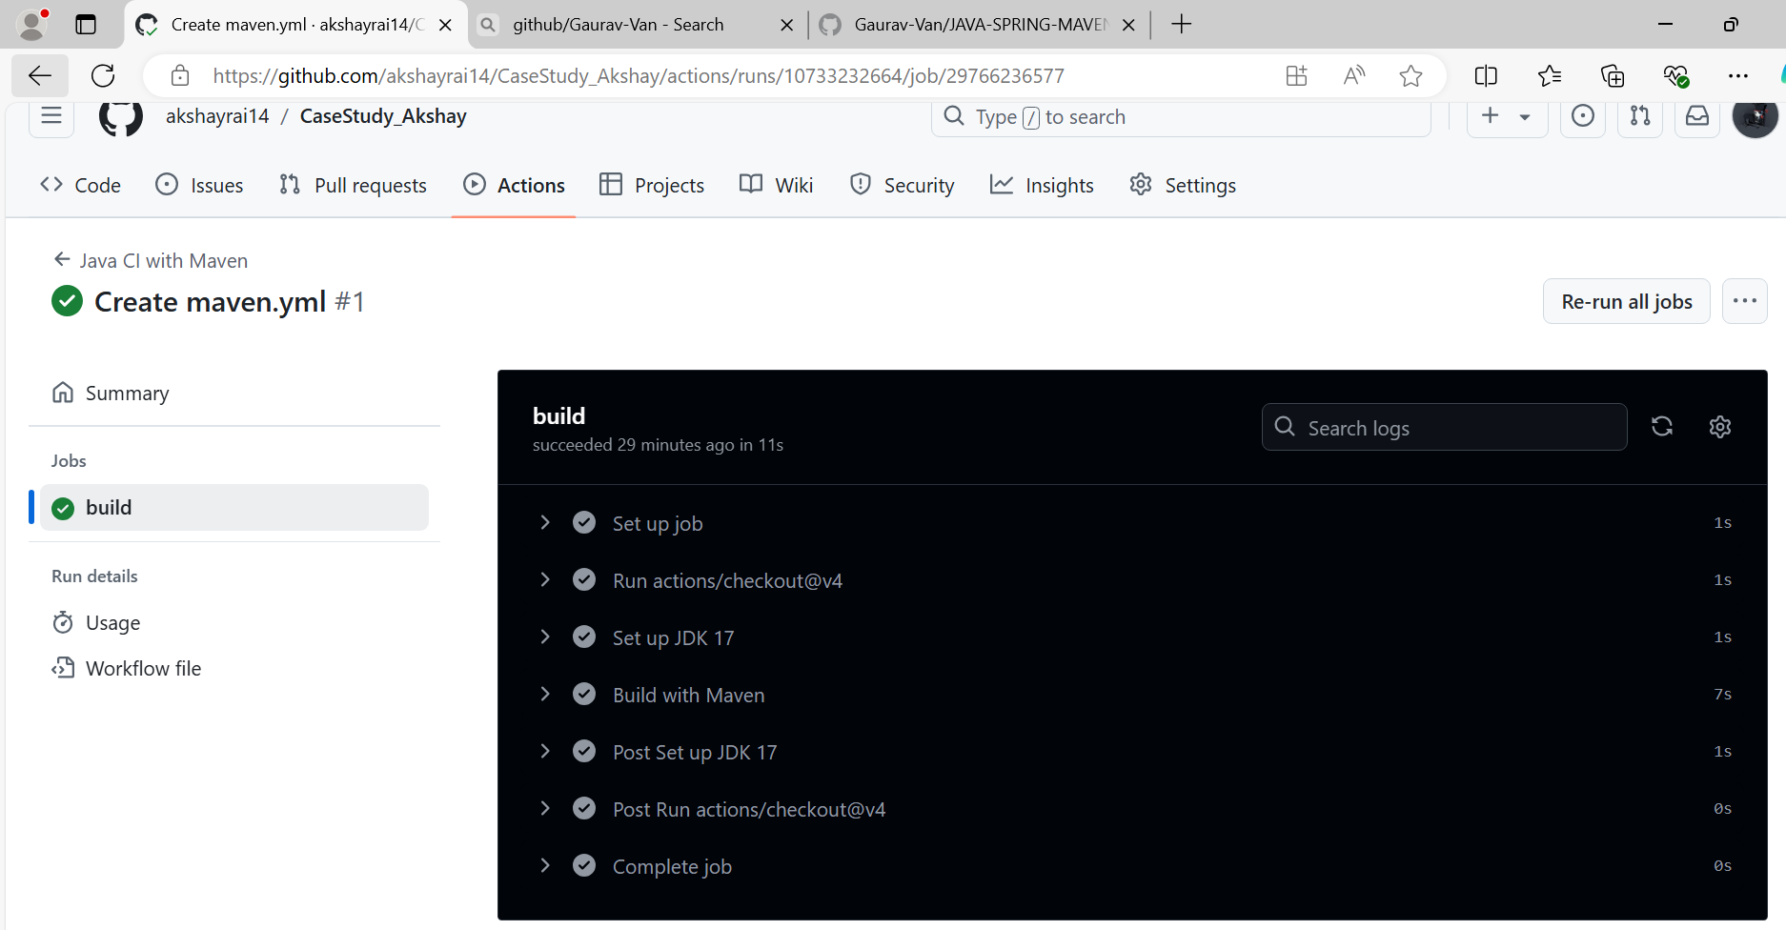  
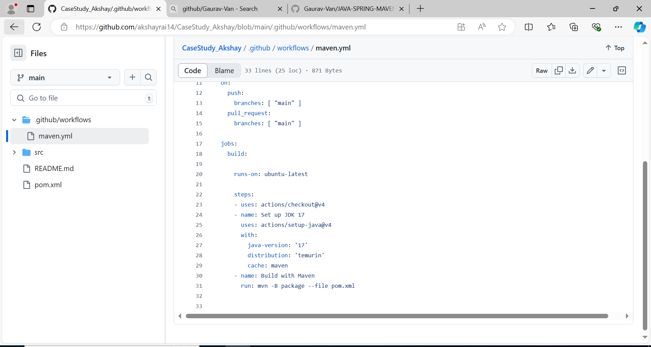  
  
BUILD SUCCESS AFTER CHANGES-  
Changes I have done-  
Removed all the comments   
Added a print statement for “Adding changes .. ”  
